
GroupBuild Email Strategy

1. Tiered Hybrid Email Architecture

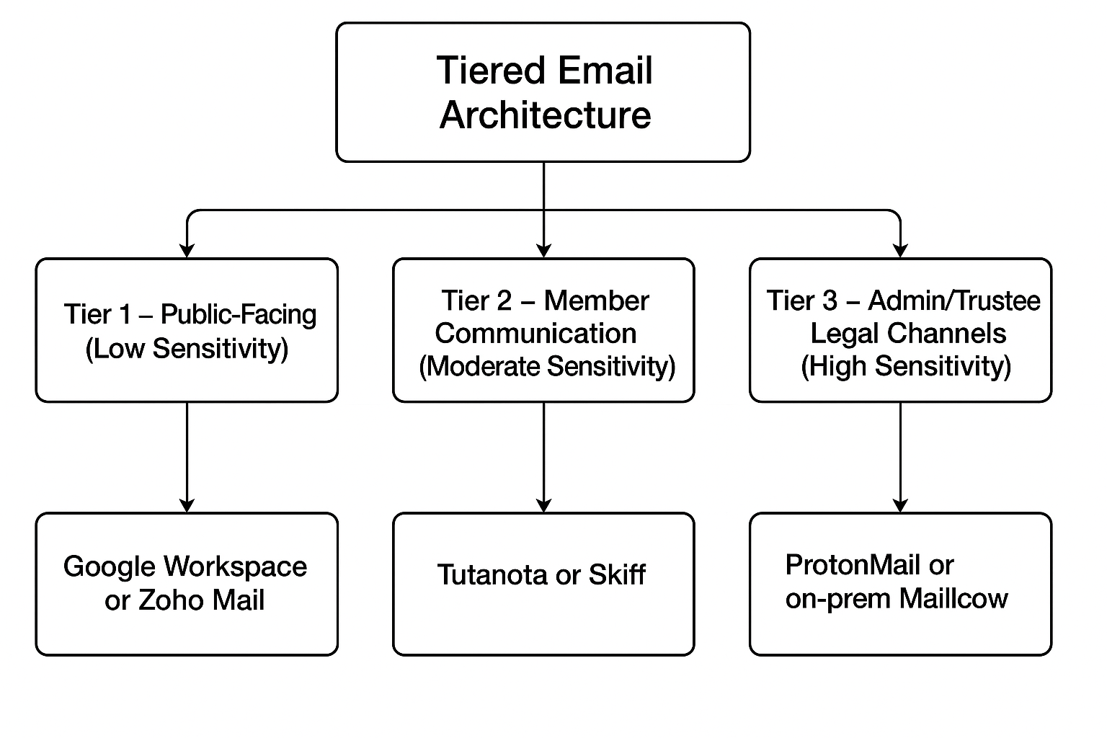
Tier 1 – Public-Facing (Low Sensitivity)
- Purpose: General info, newsletters, event invites, contact forms
- Provider: Google Workspace or Zoho Mail
- Notes: High deliver-ability, easy tools, good spam filters

Tier 2 – Member Communication (Moderate Sensitivity)
- Purpose: Group chat notifications, internal updates
- Provider: Tutanota or Skiff (custom domain preferred)
- Notes: Strong privacy, metadata shielding, encrypted comms

Tier 3 – Admin/Trustee/Legal Channels (High Sensitivity)
- Purpose: Sensitive complaints, legal and trustee communications
- Provider: ProtonMail or self-hosted Mailcow with Tor access
- Notes: Full encryption, hidden inboxes, maximum control

2. Security Layers

- Metadata minimization via encrypted providers
- DNSSEC + DANE for self-hosted options
- OpenPGP keyserver integration
- Mandatory 2FA / MFA for all admin/moderator logins
- Domain segregation for role-based routing
- Anonymous intake forms for whistleblowers or sensitive tips

3. Threat Matrix

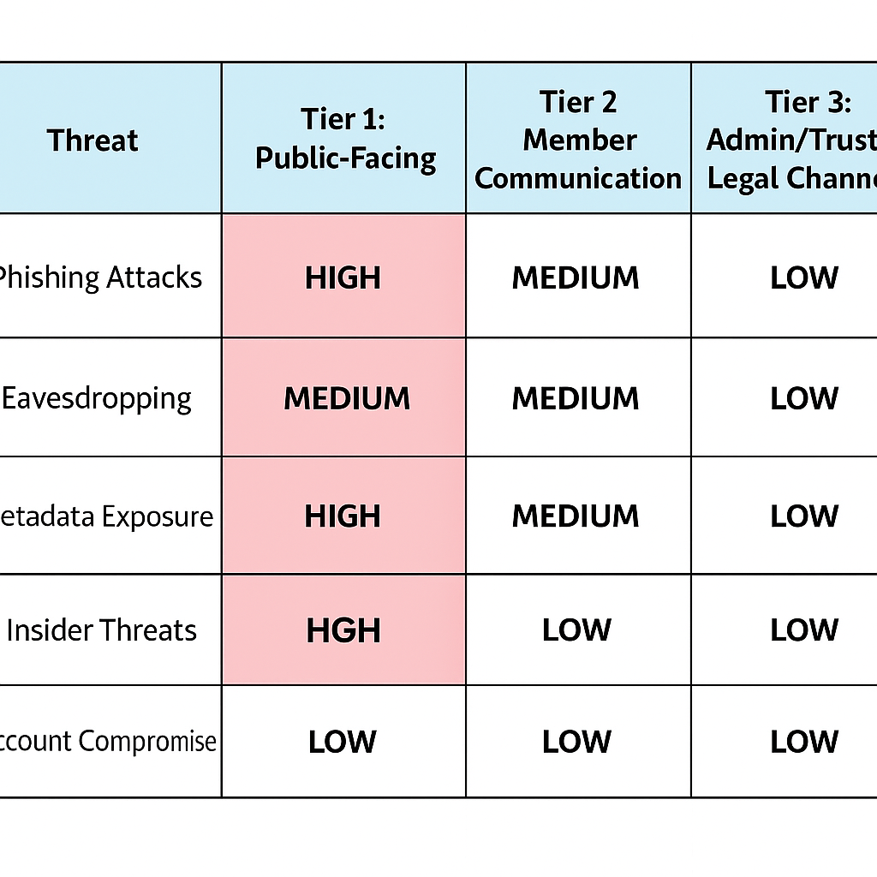
4. Implementation Checklist

- - Register domain and configure SPF/DKIM/DMARC
- - Set up public email through Zoho or Gmail
- - Secure team and trustee comms via ProtonMail/Skiff
- - Create anonymous intake channel (form or bot)
- - Enable MFA and set device access restrictions
- - Periodically review alias use and audit access logs

5. Suggested Providers and Pricing

Provider | Use Tier | Monthly Cost | Key Features
ProtonMail | Tier 3 | $5–10 | End-to-end encryption, zero-access
Skiff Mail | Tier 2 | Free–$10 | Encrypted, anonymous IDs
Zoho Mail | Tier 1 | $1–4 | Business mail, SPF/DKIM/DMARC
Google Workspace | Tier 1 | $6 | High deliverability, productivity tools
Tutanota | Tier 2 | $1.20–$7.20 | Encrypted and privacy-first
Mailcow (self-hosted) | Tier 3 | ~$10–15 | Full control, advanced use

